Web Application

After completing the model, this study also developed a website using Streamlit to help pregnant women easily predict their risk of prenatal depression. As shown in Figure 1, the homepage of the website contains the name "Maternity Health Guide" and a menu bar. The home page also contains a brief introduction of prenatal care and provides insights on how pregnant women can deal with negative emotions during pregnancy. This indirectly helps pregnant women and their families understand prenatal depression and provides some basic prevention and treatment methods.

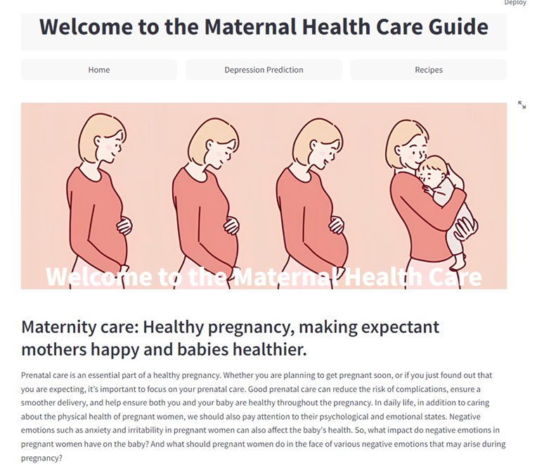

Figure 1: Home page

The second page of the website focuses on the risk prediction assessment of prenatal depression and contains four accessible relationship diagrams of factors influencing prenatal depression. The risk prediction of prenatal depression is developed based on the logistic regression model. The relationship graph is integrated with the search tool through Streamlit visualization. As shown in Figure 2, users enter their actual information according to the prompts and click the "Predict" button. The system will analyze based on the pre-set model, and users will receive the prediction result shown in Figure 3, including risk assessment, probability of prenatal depression, and important tips based on risk level. This is the customized function that can provides practical and reliable support for pregnant women, helping them better understand and manage their health conditions, and make timely decisions and interventions according to their symptoms.

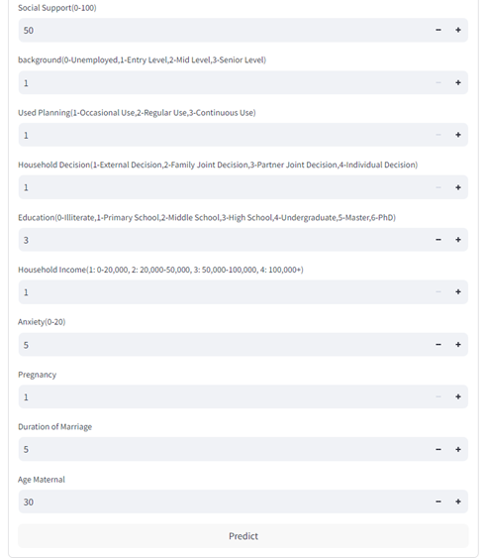

Figure 2: predict input

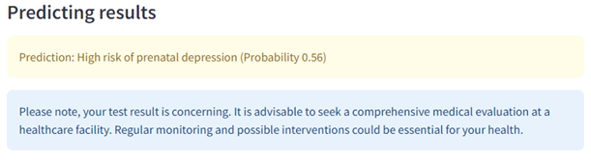Figure 3: predicting result

In addition, to help users have a deeper understanding of the influencing factors related to prenatal depression, through the relationship diagram shown in Figure 4, users can have a more intuitive understanding and interpret the influencing factors of prenatal depression from different perspectives.

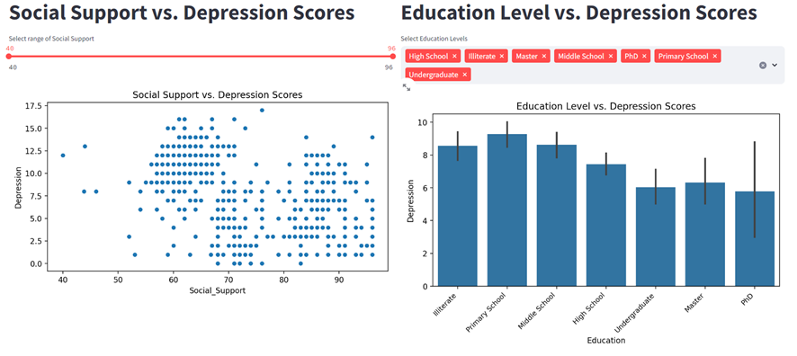

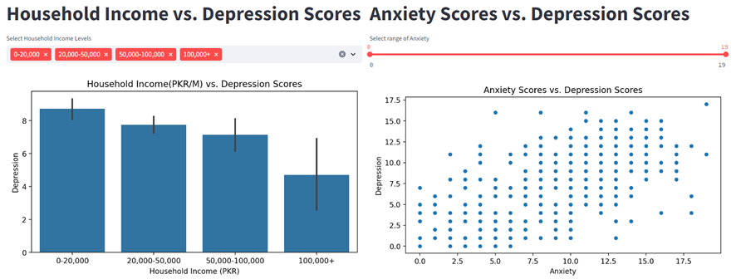

Figure 4: relation chart

The last page offers dietary recommendations for pregnant women, as shown in Figure 5. Nutrition during pregnancy is crucial for the health of both the pregnant woman and the newborns. In this special stage proper nutrient intake not only ensures the health of the pregnant woman but also positively promotes the growth and development of the fetus. Therefore, the last page of the website provides information on the essential nutrients needed during pregnancy, including their health benefits and recommended daily or weekly intake.

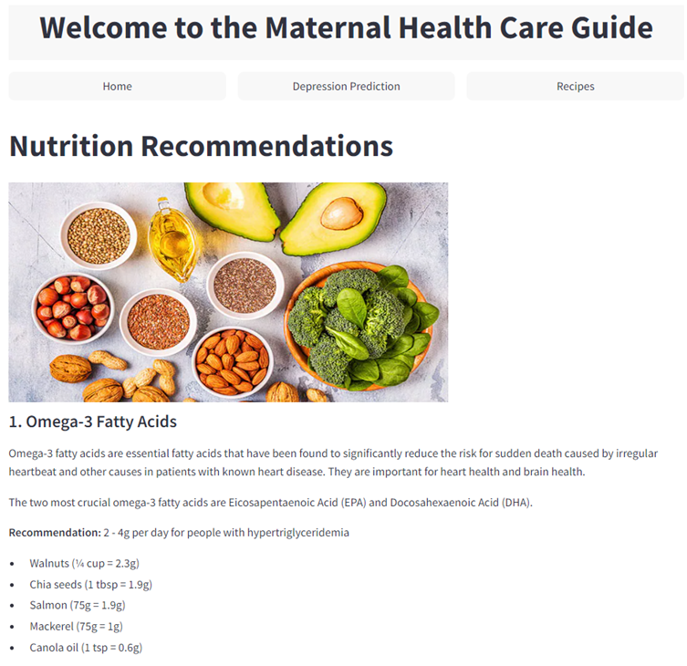

Figure 5: recipes